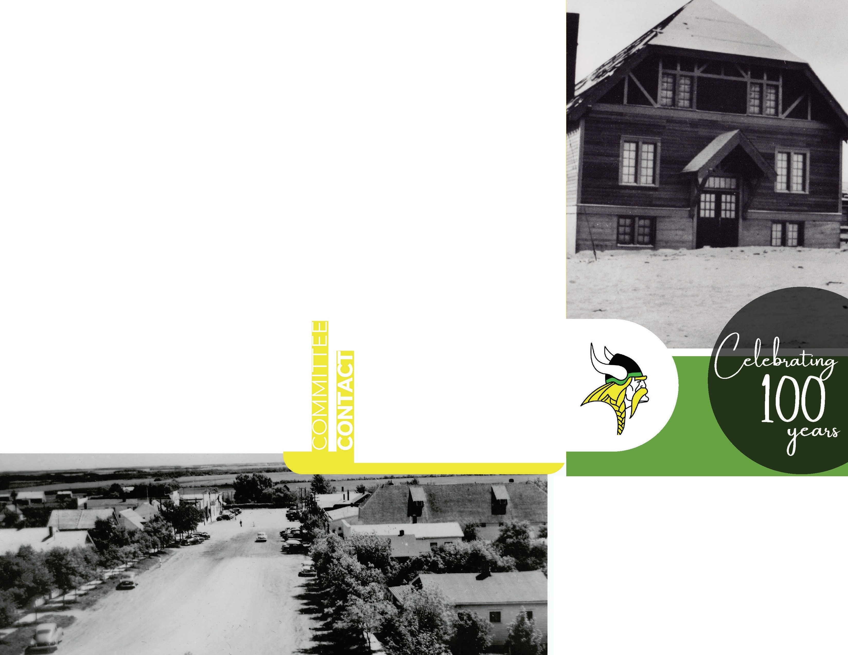

REGISTER TO VOLUNTEER

TOWN OF NAICAM WEBSITE
WWW.TOWNOFNAICAM.CA
OR

CONTACT DOROTHY CROPPER

306-874-7530

JULY

2022
*FORMS ALSO AVAILABLE AROUND TOWN

BECOME A SPONSOR

CONTACT:
JENNIFER KIM PETERSON OR ROBINSON

306-87 4-7232 306-874-7890

Facebook
Naicam Homecoming 2022

Website www.townofnaicam.ca

Email
naica mdcc@g mail.com
crop perka ren@hotmail.com
Phone
1-306-874-2280

JULY 1-3, 2022

